**Causal Loop Diagram**

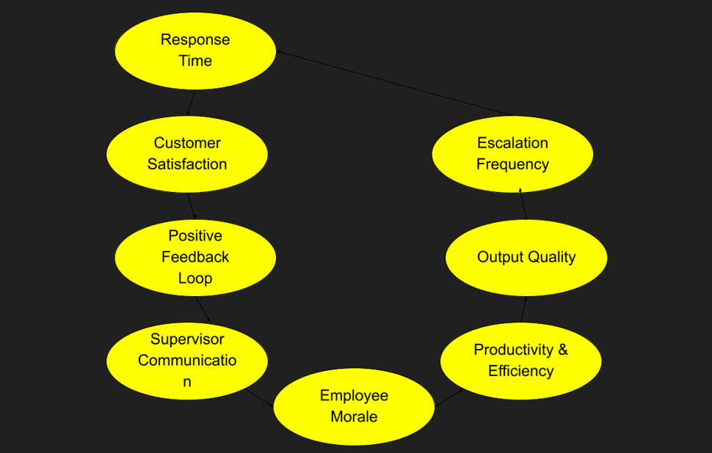

This diagram presents a feedback loop model that shows how internal workplace dynamics impact customer outcomes. Strong Supervisor Communication boosts Employee Morale, enhancing Productivity & Efficiency and Output Quality, which reduces Escalation Frequency and improves Response Time (MBAYA et al., 2024). This leads to better Customer Satisfaction, creating a Positive Feedback Loop. In the real world, such models help organizations identify root causes of performance issues, prioritize leadership development, and design interventions that improve both employee experience and customer service (Mohanty & Kulkarni, 2023). It enables data-driven decision-making and continuous improvement, especially in service-oriented industries like IT support, healthcare, or customer service.

**References**

MBAYA, I. I. H. A., FOWOSERE, S. O., OLUMUYIWA, A., & CHINEDUM, A. P. (2024). TEAM-BUILDING: A SUREFIRE STRATEGY TO ENHANCE MORALE AND PRODUCTIVITY IN THE WORKPLACE. *University of Africa Journal of Governance and Politics*, 51. <https://www.researchgate.net/profile/Tamaramiebi-Emmanuel-Timidi/publication/387787804_MANAGING_EDUCATIONAL_RESOURCES_IN_A_RECESSED_ECONOMY_IN_NIGERIA_PROBLEMS_AND_PROSPECTS_DURING_THE_MUHAMADU_BUHARI_CIVILIAN_ADMINISTRATION_2015-2023/links/677d2b36117f340ec3fb489e/MANAGING-EDUCATIONAL-RESOURCES-IN-A-RECESSED-ECONOMY-IN-NIGERIA-PROBLEMS-AND-PROSPECTS-DURING-THE-MUHAMADU-BUHARI-CIVILIAN-ADMINISTRATION-2015-2023.pdf#page=59>

Mohanty, V., & Kulkarni, M. (2023). Employee Experience approach to Leadership development. <https://papers.ssrn.com/sol3/papers.cfm?abstract_id=5140901>